Assignment 7: Linear Regression

*Note: Report your code and output whenever using R to compute findings.*

**Section 1. Regression Basics**

1. (1 pt) Why is it unrealistic for most social science research questions to assume a *deterministic* relationship between 2 variables? (provide 2 reasons)
2. (3 pts) In a bivariate linear regression equation *Y* = *a* + *bX*
   1. What is the dependent and what is the independent variable in this equation?
   2. What does the intercept (*a*) in this equation mean?
   3. What does the slope (*b*) in this equation mean?
3. (1 pt) How does that the regression slope coefficient relate to the covariance and product-moment correlation?
4. (1 pt) Write down the bivariate linear regression equation for the predicted *Y* variable (*Y*-hat)
5. (1 pt) How is the error variable *e* mathematically defined in linear regression (hint: use an equation to mathematically define a variable)?
6. (1 pt) How can the coefficient of determination be calculated in a linear regression analysis? Show an equation and write a description of the equation
7. (1 pt) What kinds of sums of squares are considered in linear regression analysis?
8. (1 pt) Professor Braun computes a linear regression to examine the relationship between studying and exam scores. She finds that students who did not study for their exam are expected to score 32 points. For each additional hour that a student studies, the average increase in the number of points on the exam is 6 points. Based on this information, write the linear equation for the observed Y scores.

**Section 2. Regression Interpretation.**

Dr. Balin examined the linear relationship between PhD interest (predictor; range: 1-5) and changes in academic self-efficacy (outcome; range: 1-5) in R, finding the following results.

ANOVA Table.

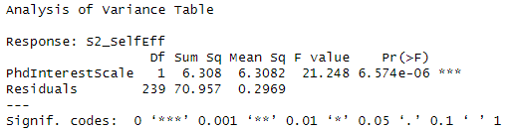

Linear Model Summary Results.

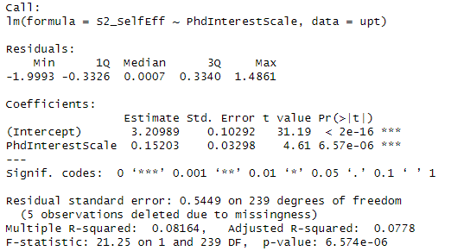

1. (1 pts) Using the above information, write the linear model equation from the results.
2. (5 pts) Draw (as accurately as possible) a regression line in the graph below. Assume 0 is at the origin, and each shown line reflects a 0.5 increase in value.

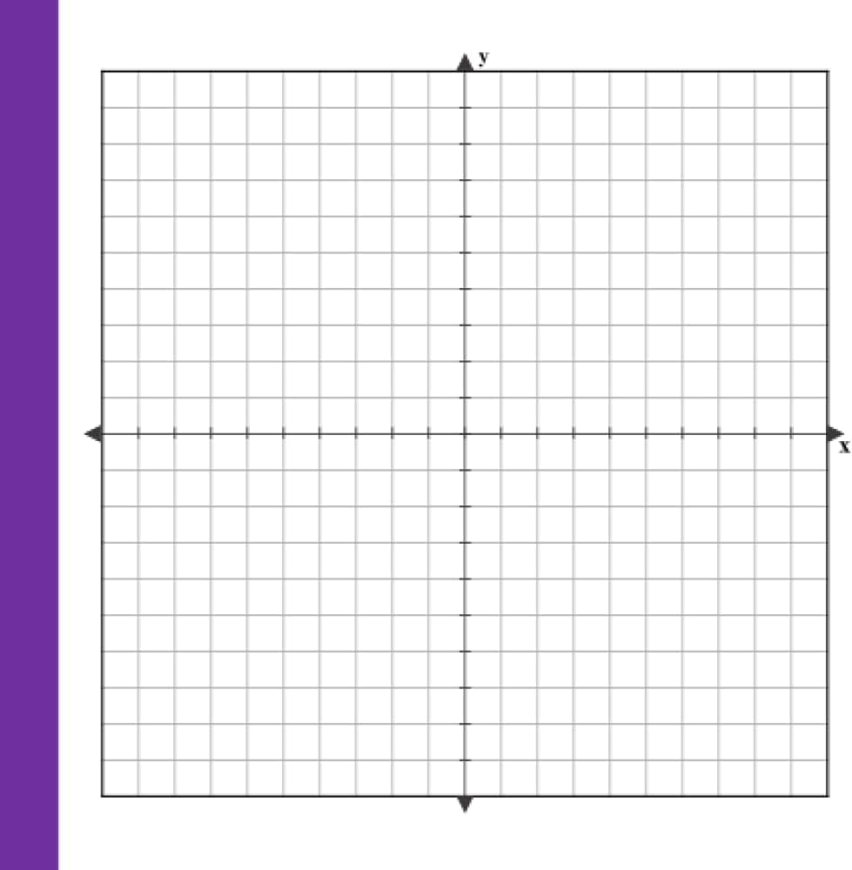

1. (3 pts) What is the predicted value of academic self-efficacy if PhD interest is
   1. 4.5?
   2. 2?
   3. 0?
2. (7 pts) Complete a sample paragraph write-up of these results.
3. (4 pts) What is missing in the analysis output that would help you interpret results more accurately?